Steps
After reviewing the resources for this assignment, do the following steps…
1: Start a Word document, making sure you start with your name, the assignment name and the due date.
2: On your PC or on the Windows VirtualBox installation, open the Command Prompt.
- As an alternative, with the Windows Key pressed, tap R for the Run Window, and type in cmd
- Type Exit to leave the Command Prompt
- In the Search Area, type cmd, and the Command Prompt should be an option
- Take a screenshot of the Screen and insert it into the document with the caption Command Prompt
- Open PowerShell using either method above, except using PowerShell in place of cmd
- Take a Screenshot of the screen and insert it into the document with the caption PowerShell screen
- Perform each of the Windows commands listed in the table below. Each time take a screenshot and insert it into the document with a caption of which command was used and what it did.
- When finished, type exit to close the terminal Window.
3: In the Linux system on your VirtualBox, open the terminal. How to open a terminal window varies by operating system. Take a screenshot of the Linux Terminal and
- Perform each of the Linux commands listed in the table below. Each time take a screenshot and insert it into the document with a caption of which command was used and what it did.
- When finished, close the terminal window.
Note: For Mac users, the terminal window in your OS will operate just like a Linux Terminal window since MacOS is a close relative of Linux based on the Unix Kernal just like Linux is.
Using my own PC system:
Command Prompt:
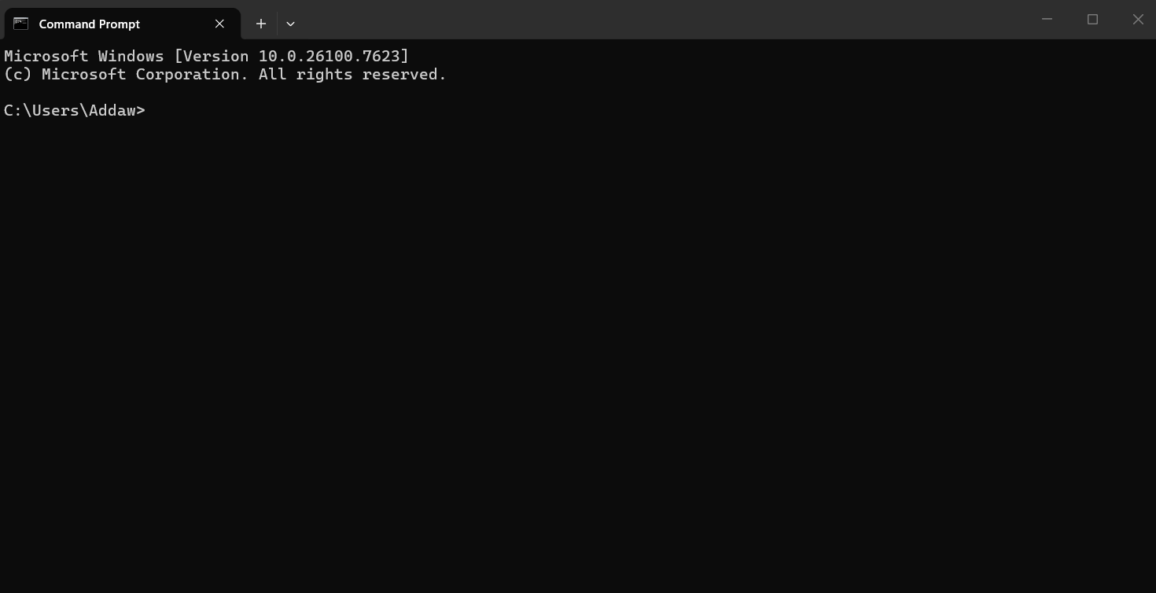
PowerShell screen:
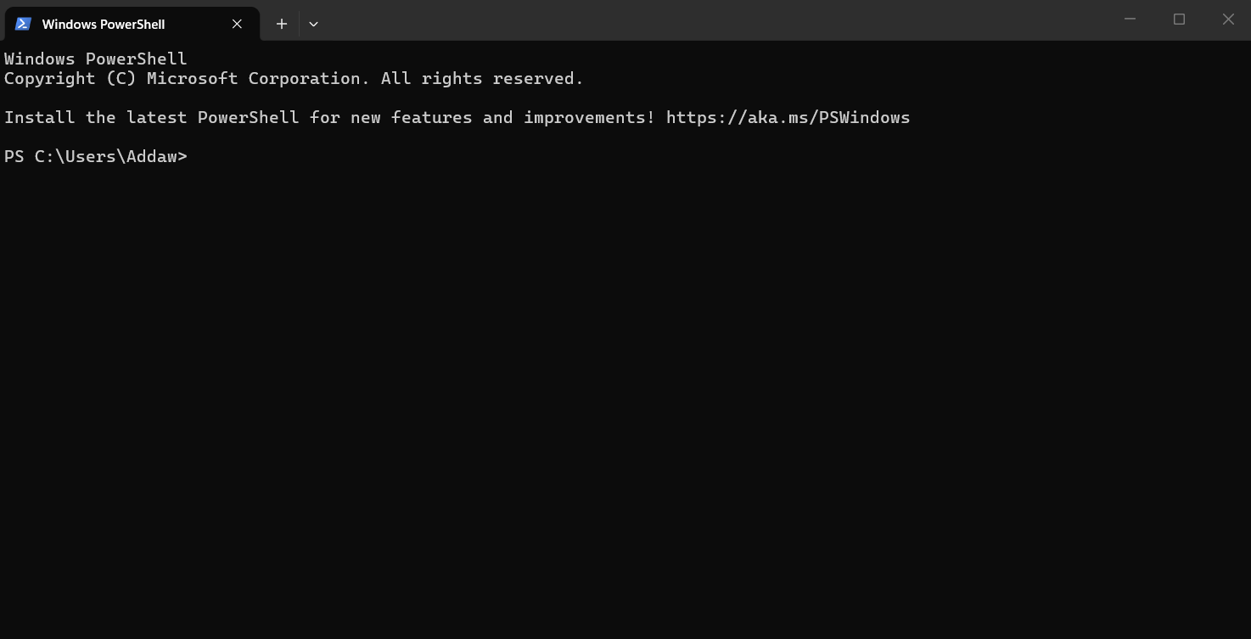
Dir: Shows the contents of the directory you are currently in.
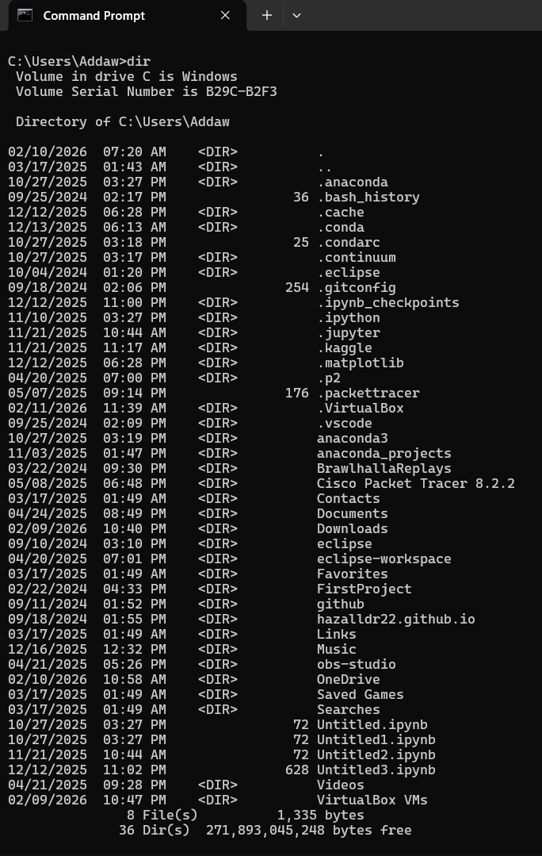
Cat: The cat command doesn’t work on the Windows command prompt. Fortunately, the “type” command is the cat alternative for cmd. In this case I output a log from VirtualBox (It ended up being super long as you can see from the scroll bar on the left side). You may need to zoom in the see everything.
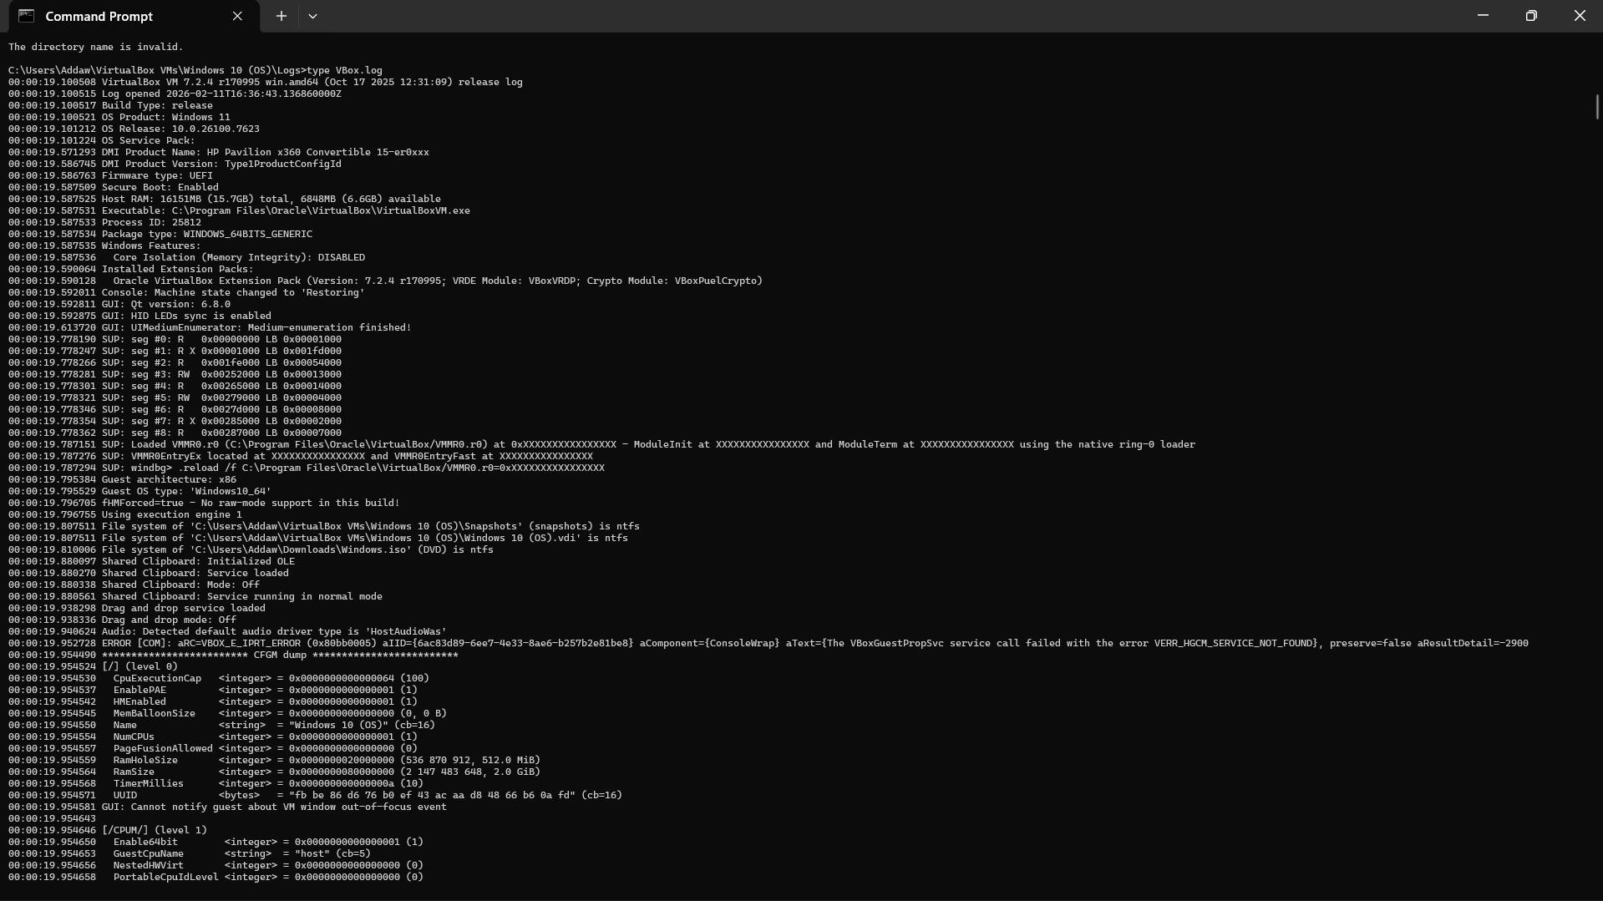
Md test: This command creates a directory named test in the current directory.
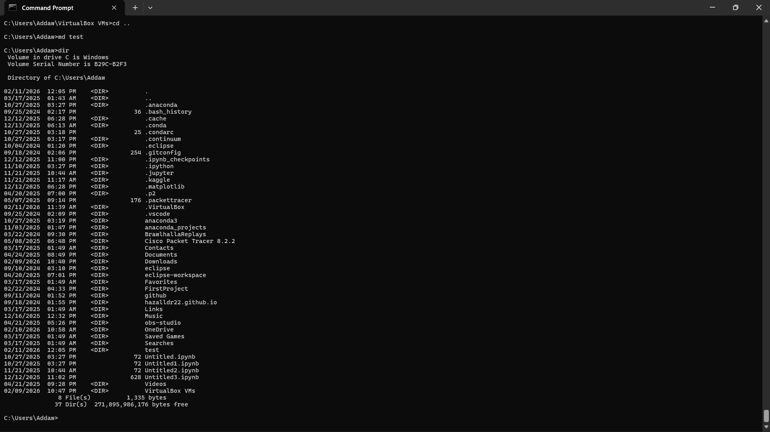
Cd test: This command changes the working directory to the test directory we just made.
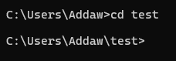
(Cd ..): This command brings the working directory one backwards in the file path.
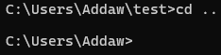
Rd test: Removes the test directory we just made. I also used the dir command to show that it was removed.
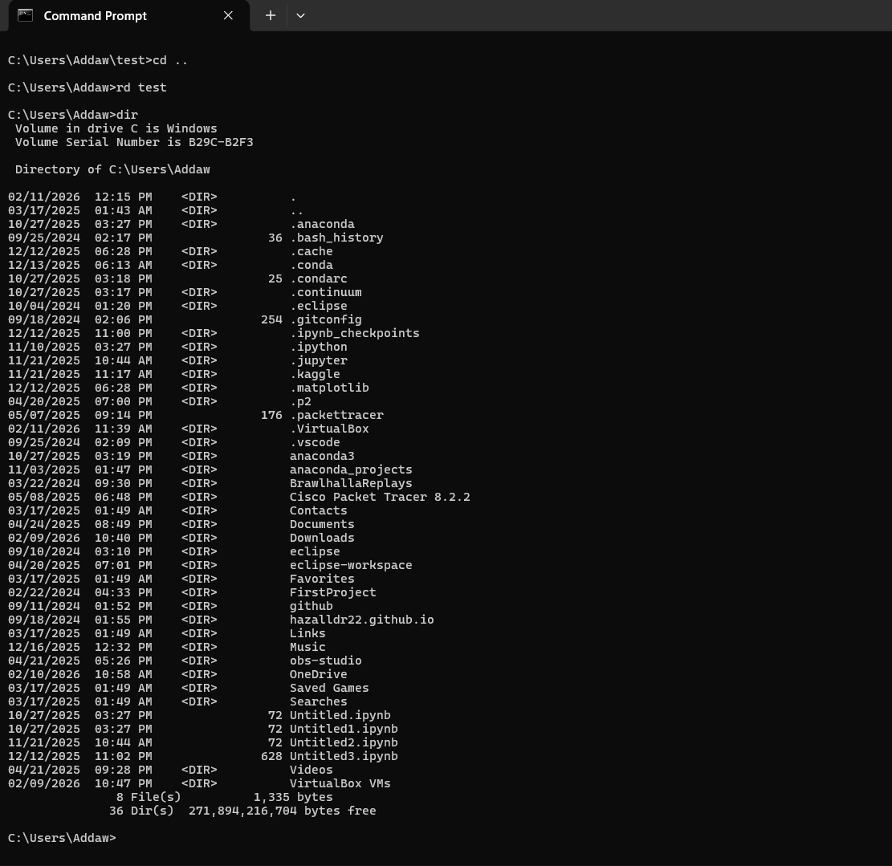
Ipconfig: This command outputs the network adapter settings. It shows important information such as the IPv4 address.
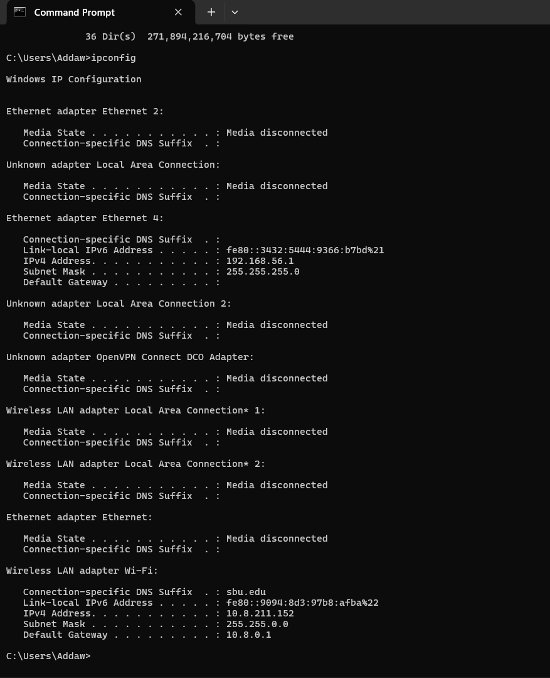

Cls: This command clears everything that was output in the current cmd session.
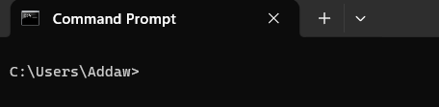

Using VM Linux:
Linux command line:
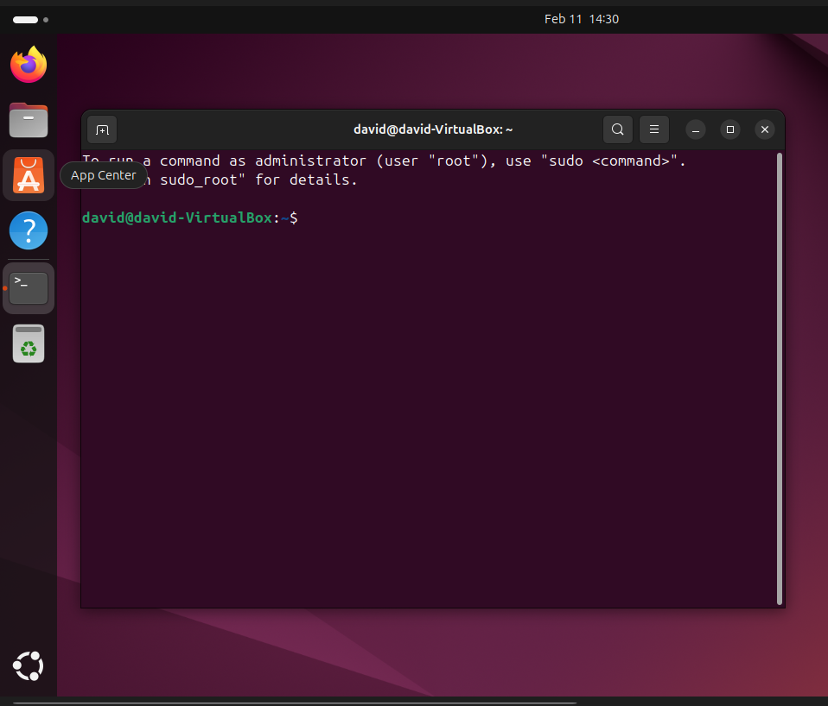
Ls: Lists the contents of the current directory.
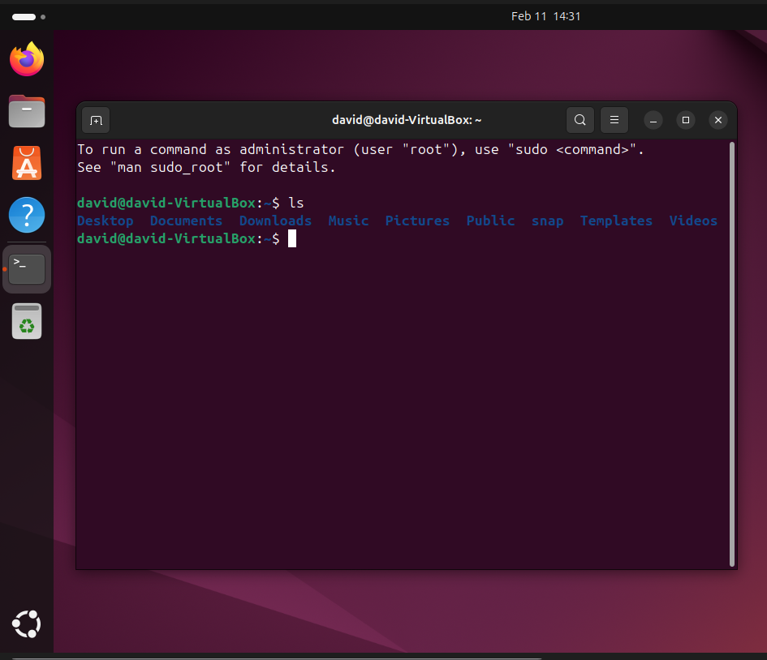
Cat: This stands for concatenate, which when called outputs the contents of a file. In my case, I created a test file in my test directory so that the cat command would run. I have nothing in the file, so nothing is output.
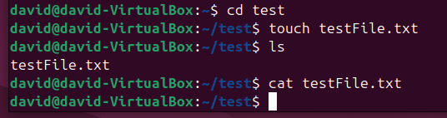
Mkdir test: Creates the test directory.
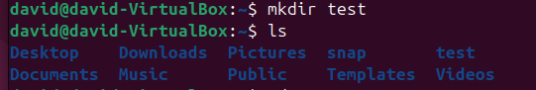
Cd test: Changes the working directory to test.
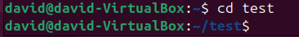
(Cd ..): This command brings the working directory one backwards in the file path. (Same as cmd)
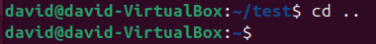
rm test and rmdir test: In my case I made a file in the test directory, so I had to use “rm testFile” before I could remove the directory. Then, I removed the directory using “rmdir test.”
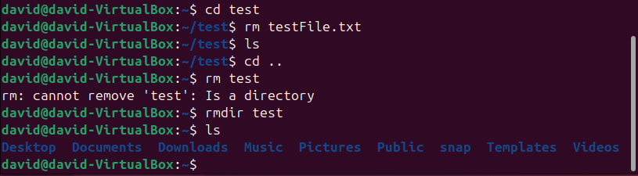
Ifconfig (ip address): On the updated Ubuntu VMs, ifconfig isn’t installed by default so I used “ip address” which works the same. This command similarly outputs important network adapter information.
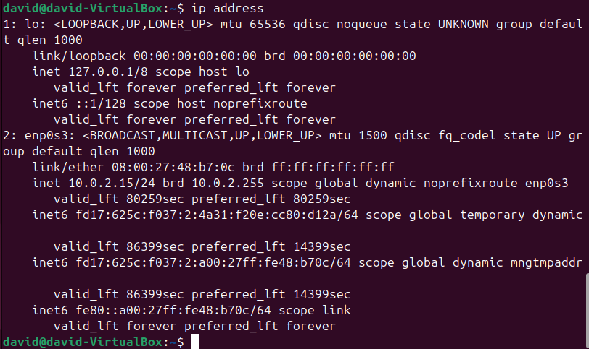
Clear: Clears all previous prompts and information.
